**Polymerase chain replication& DNA gel electrophoresis**

1. **Polymerase chain replication (PCR)**
2. **DNA gel electrophoresis**
3. **Function:** analysis of nucleic acids and proteins.
4. **Agarose gel**
5. **Goal:** Agarose gel electrophoresis is routinely used for **the preparation and analysis of DNA.**
6. **Function: slow the movement of DNA and separate by size.**
7. **DNA**
8. DNA is negatively charged. migrate toward the **positive pole (anode)**
9. Small DNA move faster than large DNA
10. **Agarose:** linear polymer extracted from seaweed.
11. **Loading Buffer(6X)**
12. **Goal:**
13. allows the samples to be seen when loading onto the gel,
14. increases the density of the samples, causing them to sink into the gel wells
15. **Composition**(0.25% bromphenol blue, 0.25% xylene cyanol, 30% glycerol).
16. Bromophenol Blue (for color and contains a negative charge)

PS: Bromophenol blue will run in the same direction as the DNA.

1. Glycerol (for weight)
2. **DNA Ladder:** DNAs of know sizes, help determine the sizes of unknown DNA
3. **Staining gel (Gel Red):**
4. **Advantages:**
5. More sensitive
6. Less toxic
7. No hazardous waste disposal
8. **Time:**

can be added to the gel and/or running buffer before the gel is run or the gel can be stained after it has run.

1. **Gel imaging:**

under UV exposure

**（6） Primer**

1) Primer length should be **15-30 nucleotide residues (bases).**

2) Optimal **G-C content** should range between **40-60%.**

3) The 3' end of primers should **contain a G or C in order to clamp the primer**

and **prevent "breathing" of ends,** increasing priming efficiency.

Ps: DNA "breathing" occurs when ends **do not stay annealed but fray or split apart.**

The three hydrogen bonds in GC pairs **help prevent breathing** but also **increase the melting temperature of the primers.**

4) The 3' ends of a primer set,

* **a plus strand primer and a minus strand primer, should not be complementary to each other**, nor can
* the **3' end of a single primer be complementary to other sequences in the primer.**

These two scenarios result in formation of **primer dimers**

**hairpin loop structures**

5) **Optimal melting temperatures (Tm) for primers range between 52-58 °C,**

6) **Di-nucleotide repeats (e.g., GCGCGCGCGC or ATATATATAT) or single**

**base runs (e.g., AAAAA or CCCCC) should be avoided**

* as they can cause **slipping along the primed segment of DNA and or hairpin loop structures to form.**
* If unavoidable due to nature of the DNA template, then o**nly include**

**repeats or single base runs with a maximum of 4 bases.**

1. **Procedure**
2. **Design PCR oligo primers for gene replication**
3. **Gene replication via PCR method**

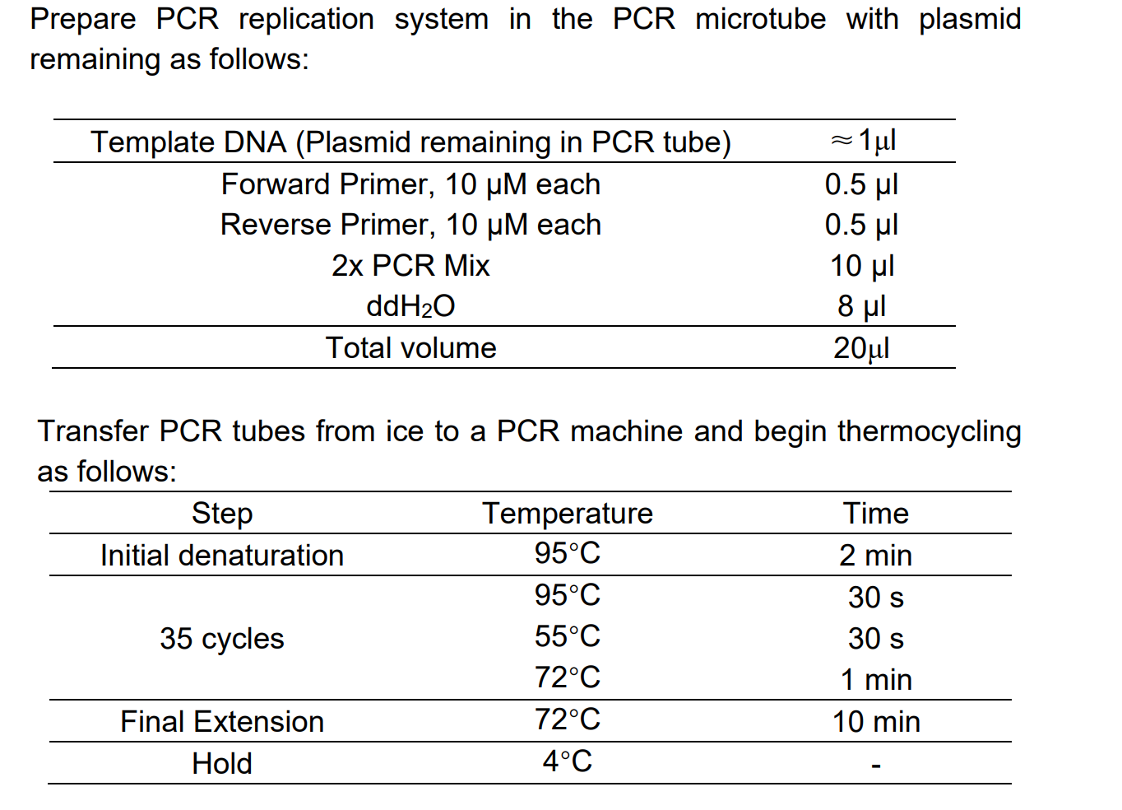

1. **Preparation of the Gel**
2. **Weigh out 0.9g agarose** into an Erlenmeyer flask and **add 60ml TAE buffer.**
3. Swirl to mix**. Melt** the agarose/buffer mixture by heating in a microwave.
4. At 30 s intervals, remove the flask and swirl the contents to mix well.
5. **Add 6µL DNA staining reagent (Gel Blue)** to the mixture and mix well by gentle shaking.
6. Place the gel tray into the casting apparatus.
7. Place an appropriate **comb** into the gel mold to create the wells.
8. **Pour** the molten agarose into the gel mold. Allow the agarose to set at room temperature (about 20 minutes)
9. **Remove the comb** and **place the gel in the gel box containing TAE buffer before use.**
10. **Add 2.5µL Ladder and 8μl DNA samples into wells.**
11. The **cathode (black leads) should be closer the wells than the anode (red leads).**
12. **Turn on the power (150V).**
13. Run the gel until the **dye has migrated to an appropriate distance (About 25 minutes).**
14. Gel imaging under **UV exposure.** DNA fragment analysis.